Bus terminal/commute

**WHY?**

* One of the proponents commutes on a bus on a daily basis when going to/from school.
* One of the proponent’s lives near BBL Pasay Terminal
* Both of the proponents know that commuting can be a dreadful process

**Methods Used:**

* Observation
* Survey
* Interview

**Observations**

* No proper queue lines
* Queue lines becomes long, especially during rush hour
* People usually experience harsh weather when waiting for buses.

**Survey/Interview**

1. How often do u ride the bus when going to/from school/work

* “Daily”
* “Very Seldom, Sometimes once a month”
* ‘Daily”

1. Do you go to a bus terminal/waiting area to get your ride?

* “Yes”
* “No”
* “Yes”

1. Is it during rush hours?

* One of the interviewees said that he rides during rush hours when he goes to/from school.
* Two said that they only ride during rush hours when going home
* One said he does not ride during rush hours.

1. If you go to a bus terminal, what kind of these do you usually experience (ex: long queues, bad weather, etc.)

* One of the interviewees said that long queues usually depend on rush hour. (Goes to PITX)
* Two said that they always experience full buses when they are going home.
* One said he does not experience any long queues even if he needs to wait for the next bus.

1. If you hail or “para” a ride outside of bus terminals what are the usual things you experience (ex: the bus is already crowded/full)

* Usually depends, but like 80 % of the time, the buses are already full (standing)
* If going to, buses are usually spacious. If going home, usually there are few seats left available despite the number of passengers. There are times were you already need to stand.

1. On a scale of 1 – 5, how do you describe your commuting experience, and why.

* The experience varies if its during rush hours or not.
* Kinda good, but not really good, there is room for improvement.
* Would give a 5 if the buses are in “pristine” condition.
* There are times where the bus seats were unconformable but has enough leg room.

**Identify user needs**

* The commuters need to know when the buses will arrive at the terminal/waiting areas

**Major insights or Breakdowns**

* People have similar experiences when commuting via buses.
* Their usual concerns mostly occur during rush hours.
* Therefore, the usual rating is 3/5 or fair.

What promising unmet needs were identified as a result?

* How to make long queues in bus terminals shorter or faster.
* How to lessen the issue of full buses, especially during rush hour.
* How to improve the experience of those who commute.

Documentation/Picture

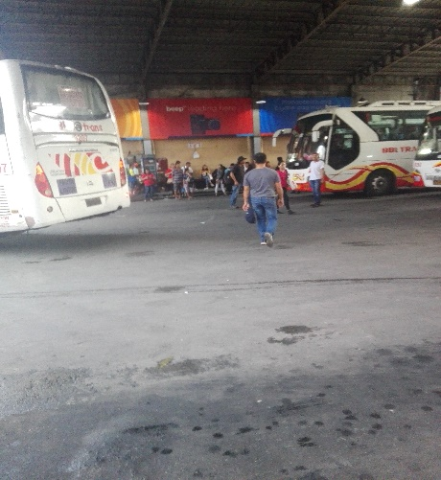 

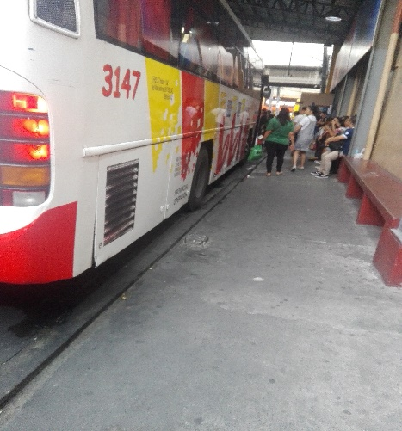 

 

Inside the bus

